

**GLOBAL FUND PROGRAM MANAGEMENT UNIT**

**SR ACTIVITY REPORT**

***Instructions:***

*This report is completed for all the outreaches undertaken by the SRs and should be submitted monthly.*

|  |  |
| --- | --- |
| **Name of SR** | DAUWOYE |
| **Date report is compiled** | 01/07/2029 |
| **Report written by:** | ROSE OMBATI |
| **Objective of Activity** | * To select youths to be trained as TOTs on EBIs intervention * To involve the youths in the implementation process of the AGYW program the region. * Selecting of qualified personnel * To follow the protocol given by the Donor in engage the youths actively in the program. |
| **Target beneficiaries (PLHIV, SW’s, and IDUs etc.)** | Youths below the age of 35 |
| **County** | KISII |
| **Sub county** | GUCHA SOUTH |

***1.0: ACTIVITY SUMMARY***

The interview was scheduled on Monday 24th and 25th Tuesday June 2019, at Nyamarambe CDF hall in South Mugirango constituency Gucha South sub county.

All shortlisted candidates turned out in large numbers, it all started well as early as 8:00am by all the participants streaming into the venue.

|  |  |  |  |  |  |  |
| --- | --- | --- | --- | --- | --- | --- |
| ***Activity description*** |  | | | | | ***Remarks*** |
| ***Activity name*** | TOTs interview on EBIs | | | | |  |
| ***Date of activity*** | 24th to 25th may 2019 | | | | |  |
| ***Facilitation methods used*** | Verbal communication, | | | | |  |
| ***Number Prevention commodities distributed*** | | | | | | ***Remarks*** |
| ***IEC materials*** | ***Condoms*** | | ***Injection Kits*** | | ***Lubricants*** |  |
|  |  | |  | |  |
| ***Number people reached*** | | | | | | ***Remarks*** |
| ***Male*** | | ***Female*** | | ***Total*** | |  |
| ***49*** | | ***45*** | | ***94*** | | ***GOOD TURN OUT.*** |

**2.0: ACTIVITY PROCEEDINGS**

On arrival the candidates for the interview registered in the attendance list provided. The interviewee panel consisted of the following members;

* Simion Aiko SCPHN Nduru Sub County Health
* Madam Winfridah Abuya DAUWOYE CEO
* Rose Ombati the program officer DAUWOYE
* Dennis Mogere THE MONITORING AND Evaluation officer DAUWOYE

**2.1: Key achievements**

* We managed to interview 90 candidates
* We selected 60 successful candidates who met the requirements as TOTs
* The activity was successful as we met the target of selecting 60 candidates

**2:2: Key actions and way forward**

The interview session was very interactive and went on well, the rating sheet had some questions which tested the different aspects i.e. going through their education certificate and other testimonies. The questions were testing their knowledge on HIV/AIDS and computer skills.

In addition to this the candidates were probed more about there working experience with the Adolescents and youths.

**3.0: LESSONS LEARNT**

* Almost all the candidates have information about HIV/AIDS.
* Many youths are unemployed

**4.0 CHALLENGES AND RESOLUTION**

* The candidates turned in large numbers
* The activity was strenuous
* Some candidates lacked the minimum requirements

**The resolution**

* Rescheduled the interview for two days
* Extended working hours to 6:00pm

**5.0: RECOMMENDATIONS AND REQUIRED ACTIONS**.

* It was recommended that the youths particularly from Gucha south sub county to be given an opportunity to implement the AGYW program.
* This program AGYW will create employment opportunity for unemployed youths

**6.0: ANNEXES**

1. List of Participants/attendance list
2. Program/timetable for the event.
3. Supporting financial documents
4. Photographs

Any other relevant attachments depending on the nature of activity

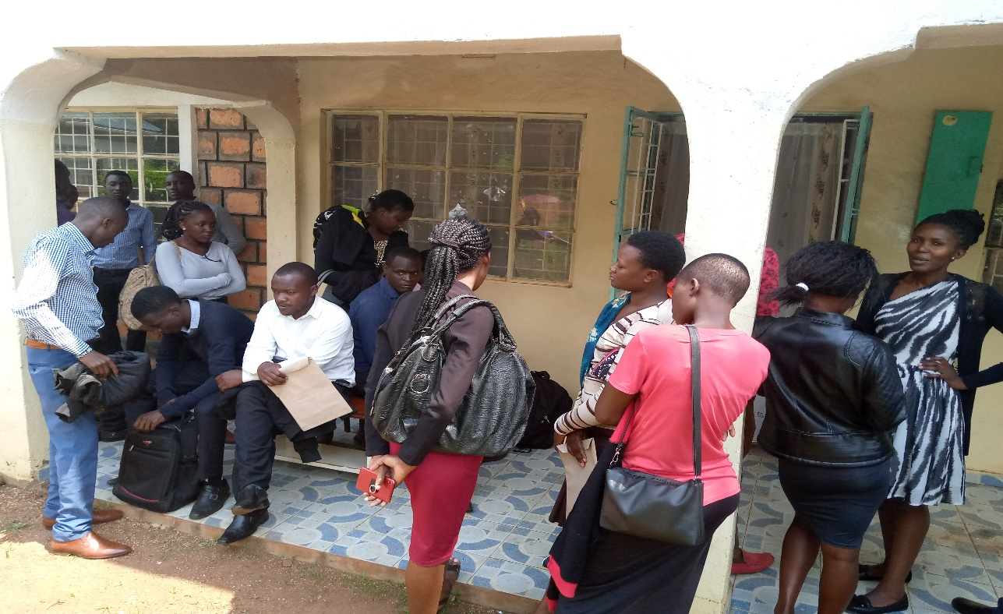  
**Photo: Candidates waiting for an interview**

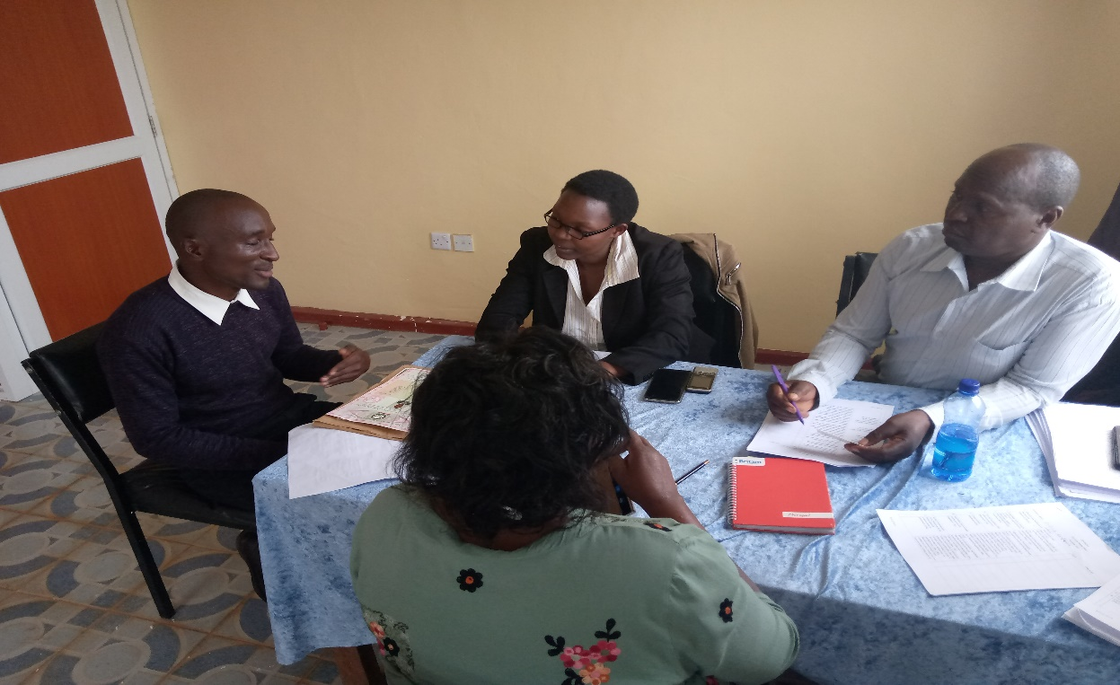

***Photo: candidate being interviewed***

***Name and Signature of Person compiling the Report Date***

02/07/2019

DENNIS MOGERE

***Name and Signature of Person approving the Report Date***

02/07/2019

ROSE OMBATI